Day | 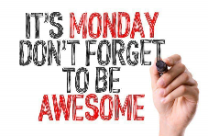  Monday | 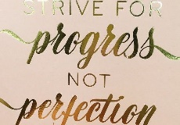  Tuesday | 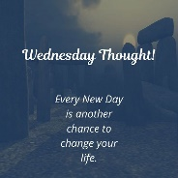  Wednesday | 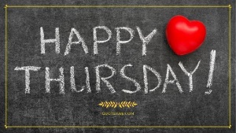  Thursday | Friday  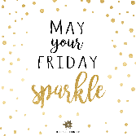 | 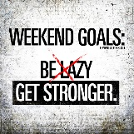  Saturday | Sunday  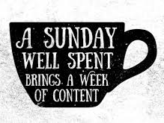
Date
Breakfast
What did you have?
What time?

Lunch
What did you have?
What time?

Dinner
What did you have?
What time?

Snacks (Morning/ Afternoon & Evening)

Water  (tick the number of glasses) | 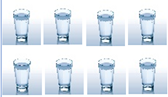
Alcohol

Mood  (circle the face) | 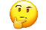
Fruit/Veg
Did you have your 5 a day?

Meal Planning & Notes Section

